SIMATS ENGINEERING
ASSESSMENT TOOL 1: Algorithm Design Challenge
COURSE NAME: ARTIFICIAL COURSE CODE: MLA01
INTELLIGENCE AND
EXPERT SYSTEMS

COURSE OUTCOME COVERED
CO2: Apply search algorithms and heuristic techniques to solve state-space search and optimization problems. (BTL 3)
Assessment Tool Weightage: 40 %

Total Marks: 100 Time: 90 Mins
No. of Questions: 5
Annexure A
Algorithm Design Challenge

Code of Conduct:

I P.N.V.CHAVIN (192525310 ) (Name / Reg No) certify that this submission is my original work and that I have adhered to the guidelines specified for this assessment.
I understand that any violation of academic integrity rules will result in disciplinary action.

Signature of the student: P.N.V.CHAVIN

Criterion | Weightage | Marks Obtained
Problem Analysis and Understanding | 15%
AI Algorithm Selection & Justification | 15%
Algorithm Design / Pseudocode | 25%
Application of AI Concepts (Greedy, A*, CSP,  Minimax, etc.) | 15%
Diagram / State Space / Search Tree  Representation | 10%
Complexity Analysis and Solution Efficiency | 10%
Originality, Critical Thinking, and Presentation | 10%
Total | 100%
Signature of the Faculty Total Marks Awarded

QUESTION 1 — GREEDY BEST-FIRST SEARCH

Design an algorithm using Greedy Best-First Search to find a path from a source node to a goal node for the given graph. Clearly define the heuristic function, show the node expansion order, and justify why Greedy Best-First Search is suitable for this problem.

1. Problem Statement
The task is to find a path from a source node S to a goal node G using an informed search strategy. Greedy Best-First Search selects the frontier node having the smallest heuristic estimate h(n), where h(n) estimates the remaining distance or cost from n to the goal.

2. Problem Analysis
Component | Definition
Initial State | S
Goal State | G
State | A node in the graph
Action | Move along an available edge
Assumption | All listed edges are traversable; heuristic values are available.
Objective | Reach G by expanding the node with the smallest h(n).
Constraint | Greedy selection is based on h(n), not accumulated path cost.

3. AI Technique Selection & Justification
Greedy Best-First Search is appropriate when a quick goal-directed search is preferred and a useful heuristic is available. Unlike Uniform Cost Search, it does not prioritize the accumulated path cost g(n). Unlike A*, it does not combine g(n) and h(n). Hence it can be faster in practice but is not guaranteed to return the shortest path.

4. State-Space Representation
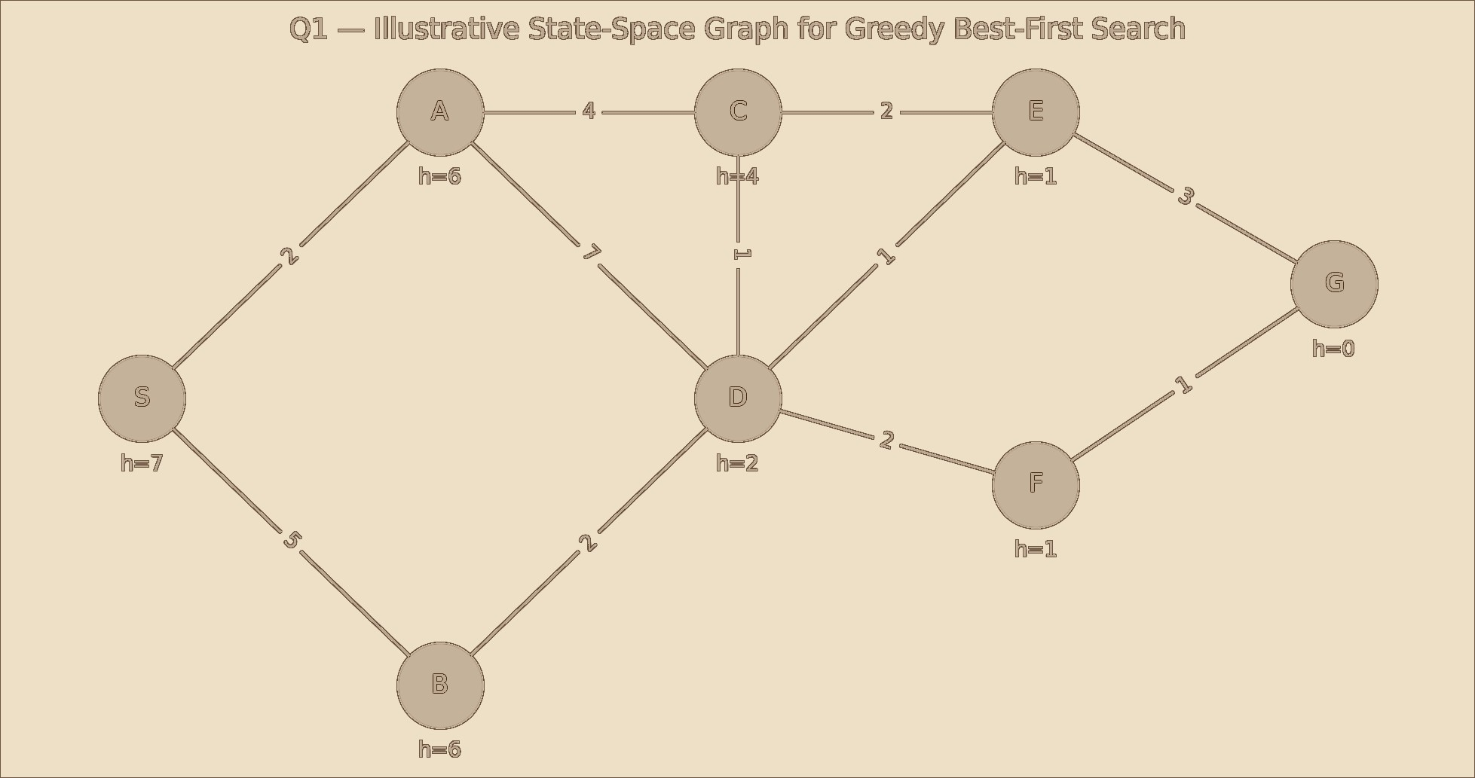
Figure 1. Illustrative graph used to demonstrate the algorithm because the supplied question paper does not include the referenced separate graph.

5. Heuristic Function
For this illustrative example, h(n) is the estimated remaining cost from node n to G. Lower h(n) means that the node appears closer to the goal.
Node | S | A | B | C | D | E | F | G
h(n) | 7 | 6 | 6 | 4 | 2 | 1 | 1 | 0

6. Algorithm / Pseudocode
GREEDY-BEST-FIRST-SEARCH(start, goal)
- OPEN ← priority queue ordered by smallest h(n)
- Insert start into OPEN
- CLOSED ← empty set
- while OPEN is not empty:
- n ← remove node with minimum h(n)
- if n = goal:
- return reconstructed path
- add n to CLOSED
- for each successor m of n:
- if m is not in CLOSED and OPEN:
- store parent(m) = n
- insert m into OPEN with priority h(m)
- return failure

7. Working / Execution Trace
Step | Expanded Node | Reason | Next Useful Frontier
1 | S | Start node | A(6), B(6)
2 | A | Lowest h among frontier (tie broken by insertion order) | B(6), C(4), D(2)
3 | D | Lowest h = 2 | B(6), C(4), E(1), F(1)
4 | E | Lowest h = 1 | B(6), C(4), F(1), G(0)
5 | G | Goal reached | Stop

8. Expansion Order and Result
Expansion order: S → A → D → E → G. The returned path in this illustrative graph is S → A → D → E → G. The important point is that selection is driven by h(n), not by total path cost.
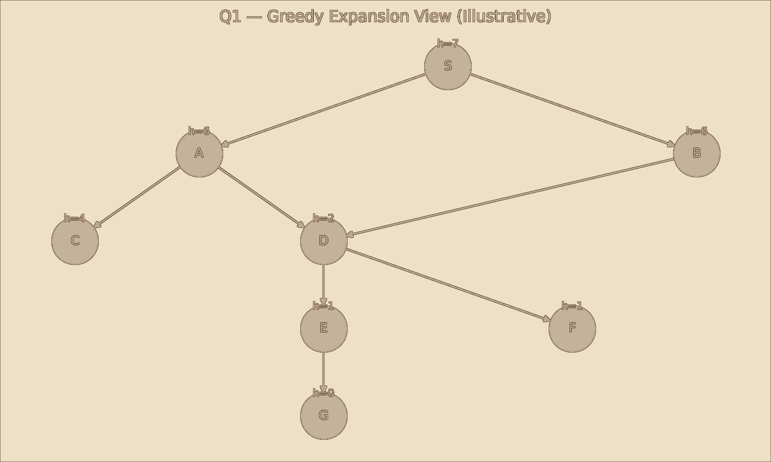

9. Complexity Analysis
Measure | Analysis
Time | Worst case O(b^m), where b is the branching factor and m is the maximum search depth.
Space | O(b^m) in the worst case because OPEN/CLOSED may store many generated nodes.
Optimality | Not guaranteed to find the minimum-cost path.
Completeness | Not guaranteed in general without additional conditions.

10. Advantages & Limitations
- Advantages: goal-directed; simple priority rule; can be fast when the heuristic is informative; useful for large search spaces.
- Limitations: ignores path cost g(n); may select a costly route; quality depends strongly on the heuristic; can be incomplete in unrestricted spaces.

11. Conclusion
Greedy Best-First Search provides a simple informed strategy for reaching a goal by repeatedly selecting the most promising node according to h(n). It is efficient for many practical searches when the heuristic is good, but A* is preferable when an optimal path is required.

QUESTION 2 — A* SEARCH
A delivery robot must travel from a warehouse to a customer through a weighted road network. Design an A* Search algorithm to determine the optimal path. Calculate g(n), h(n), and f(n) for each expanded node, and explain why A* guarantees the optimal solution.

1. Problem Statement
The robot must move from warehouse W to customer C through a weighted graph. Each edge has a travel cost. A* evaluates a node using f(n) = g(n) + h(n), combining the cost already travelled with an estimate of the remaining cost.

2. Problem Analysis
Component | Definition
Initial State | W (warehouse)
Goal State | C (customer)
State | Road-network node
Action | Travel along a connected road
g(n) | Actual cost from W to n
h(n) | Estimated remaining cost from n to C
f(n) | g(n) + h(n)
Objective | Find the minimum-cost route to C.

3. A* Selection & Justification
A* is suitable because the problem has weighted transitions and requires an optimal route. If h(n) is admissible (never overestimates the remaining cost) and the usual A* conditions are satisfied, selecting the node with minimum f(n) preserves optimality.

4. Illustrative Weighted Graph
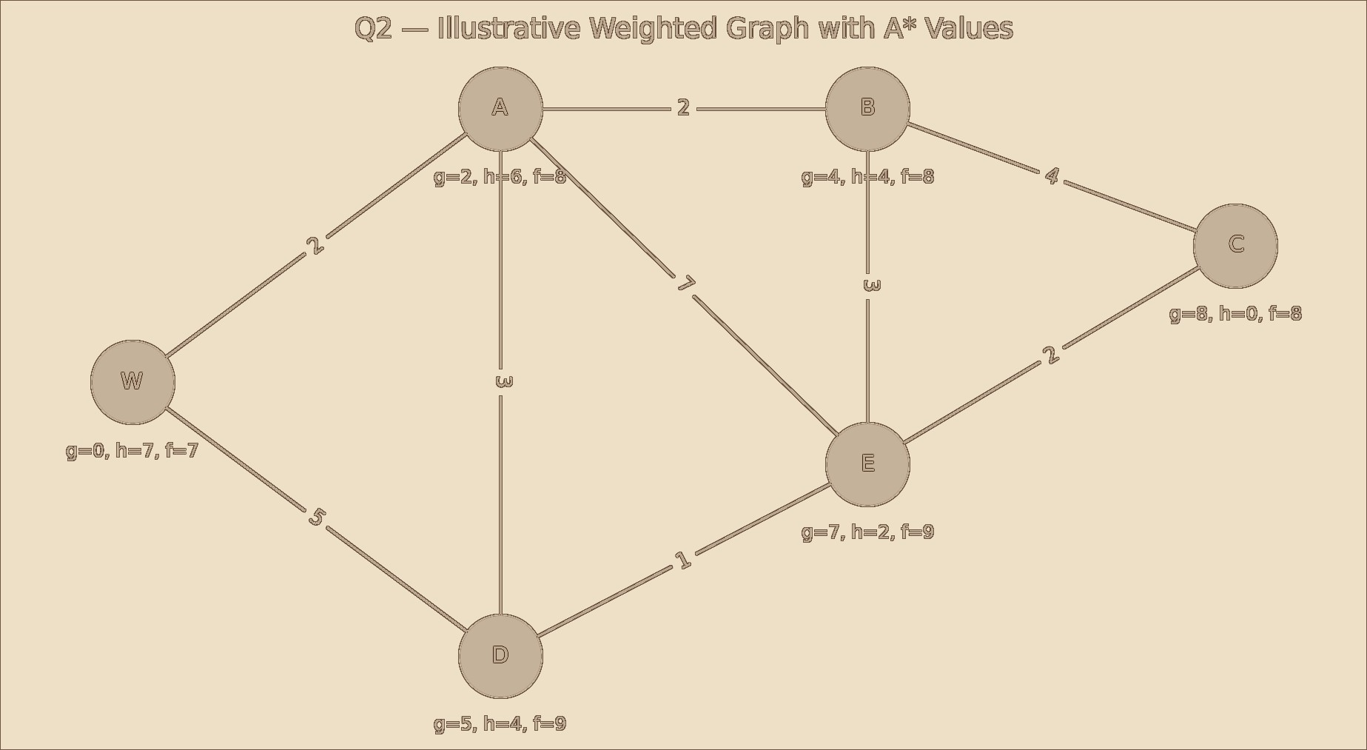
Figure 2. Illustrative weighted graph and A* values; replace with the faculty-provided graph if one was supplied separately.

5. A* Heuristic Values
Node | W | A | B | D | E | C
h(n) | 7 | 6 | 4 | 4 | 2 | 0
Example g(n) when expanded | 0 | 2 | 4 | 5 | 7 | 8
f(n) | 7 | 8 | 8 | 9 | 9 | 8

6. Execution Trace
Step | Expanded | g(n) | h(n) | f(n) | Path
1 | W | 0 | 7 | 7 | W
2 | A | 2 | 6 | 8 | W→A
3 | B | 4 | 4 | 8 | W→A→B
4 | C | 8 | 0 | 8 | W→A→B→C

The illustrative optimal route is W → A → B → C with total cost 8. The alternative W → D → E → C has cost 5 + 1 + 2 = 8 as well, so this particular illustrative graph has a tie in optimal cost. If a unique route is required for your faculty graph, use its actual edge weights.

7. A* Pseudocode
A-STAR(start, goal)
- OPEN ← priority queue ordered by smallest f(n)
- g(start) ← 0
- f(start) ← g(start) + h(start)
- CLOSED ← empty set
- while OPEN is not empty:
- n ← remove node with minimum f(n)
- if n = goal:
- return reconstructed optimal path
- add n to CLOSED
- for each successor m of n:
- tentative_g ← g(n) + cost(n,m)
- if tentative_g < g(m):
- parent(m) ← n
- g(m) ← tentative_g
- f(m) ← g(m) + h(m)
- insert/update m in OPEN
- return failure

8. Why A* Can Guarantee Optimality
- If h(n) never overestimates the true remaining cost, it is admissible.
- A* considers both the cost already paid, g(n), and the estimated remaining cost, h(n).
- The f(n) value provides a lower-bound estimate of a solution through n.
- With an admissible heuristic and appropriate graph-search handling, the first goal selected for solution has minimum path cost.

9. Complexity
Measure | Analysis
Time | Worst case exponential, commonly expressed as O(b^d) for a tree-search view.
Space | O(b^d) in the worst case because A* stores the frontier and explored information.
Optimality | Yes under standard admissibility/consistency conditions.
Practical efficiency | Improves as the heuristic becomes more informative without overestimating.

10. Advantages, Limitations & Conclusion
- Advantages: optimal with a suitable heuristic; combines actual and estimated cost; widely useful for path planning.
- Limitations: can consume large memory; performance depends on heuristic quality; poor heuristics may make it approach uninformed search.
Conclusion: A* is a strong choice for the delivery-robot problem because it explicitly balances travelled cost and estimated remaining cost. It is preferred over purely greedy search when optimality matters.

QUESTION 3 — CONSTRAINT SATISFACTION PROBLEM (CSP)
A university needs to prepare an examination timetable without scheduling conflicting subjects at the same time. Design the problem as a Constraint Satisfaction Problem (CSP) by identifying variables, domains, and constraints. Explain how MRV and Forward Checking improve the efficiency of the solution.

1. Problem Statement
The university must assign examination time slots to subjects while ensuring that subjects with common students are not scheduled simultaneously.

2. CSP Formulation
Element | Definition
Variables | X1=S1, X2=S2, X3=S3, X4=S4, X5=S5
Domain | T1, T2, T3
Meaning | Each subject is assigned exactly one examination slot.
Constraint | Conflicting subjects must have different time slots.
Goal | Find a complete assignment satisfying every constraint.

3. Variables & Domains
Variable | Subject | Domain
X1 | S1 | {T1,T2,T3}
X2 | S2 | {T1,T2,T3}
X3 | S3 | {T1,T2,T3}
X4 | S4 | {T1,T2,T3}
 | S5 | {T1,T2,T3}

4. Constraint Graph
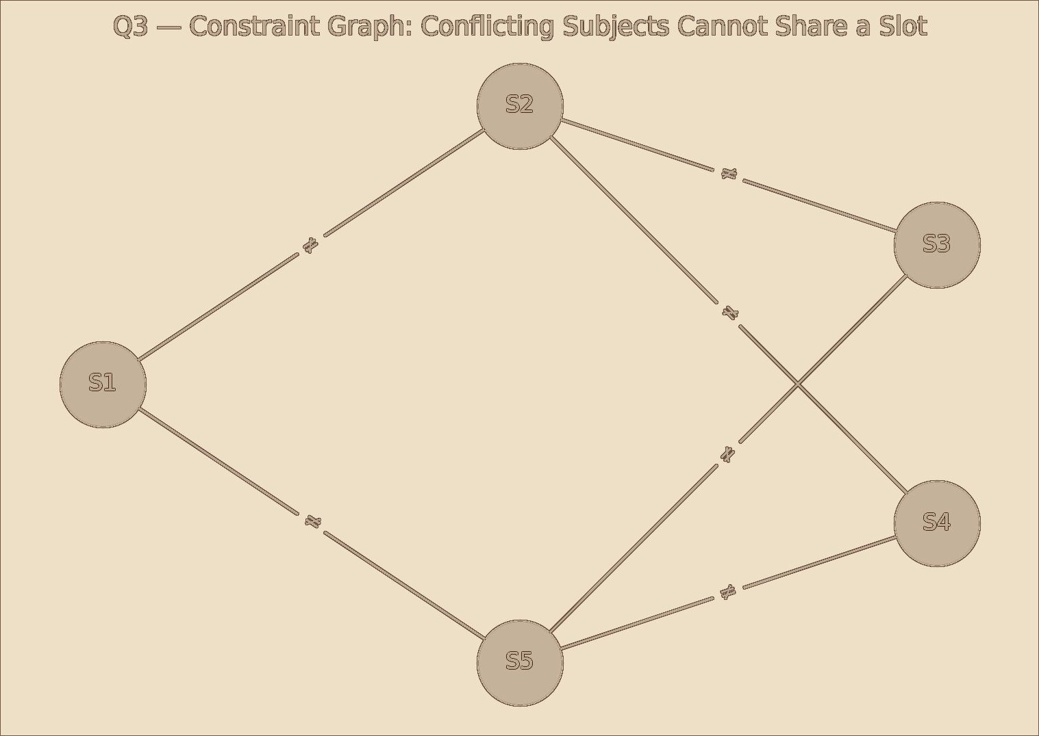
Figure 3. Illustrative constraint graph. An edge means the two subjects cannot share the same time slot.

5. Constraints
- S1 ≠ S2 and S1 ≠ S5
- S2 ≠ S3 and S2 ≠ S4
- S3 ≠ S5
- S4 ≠ S5

6. MRV Heuristic
Minimum Remaining Values (MRV) chooses the unassigned variable with the smallest current domain. It is a fail-first strategy: if a variable is difficult to assign, it is handled early, reducing wasted search.

7. Forward Checking
After assigning a value to a variable, Forward Checking removes that value from the domains of all directly connected unassigned variables. If any future domain becomes empty, the algorithm backtracks immediately.

8. Combined MRV + Forward Checking Trace

Step | Assignment | Domain Changes / Reason
1 | S1=T1 | Remove T1 from S2 and S5.
2 | S2=T2 | MRV selects S2 after its domain shrinks; remove T2 from S3 and S4.
3 | S5=T2 | S5 is compatible with S2; remove T2 from S3 and S4 if applicable through its constraints.
4 | S3=T1 | S3 is compatible with S5=T2 and S2=T2.
5 | S4=T1 | S4 is compatible with S5=T2 and S2=T2.
6 | Complete | All variables assigned with no conflict.

9. Final Timetable (Illustrative)
Subject | Slot | Conflicts Checked
S1 | T1 | S2,S5
S2 | T2 | S1,S3,S4
S3 | T1 | S2,S5
S4 | T1 | S2,S5
S5 | T2 | S1,S3,S4

10. Pseudocode
CSP-BACKTRACKING(assignment)
1. if assignment is complete: return assignment 2. X ← select unassigned variable using MRV
- for each value v in X's domain:
- if v is consistent with assigned neighbours:
- assign X = v
- apply Forward Checking
- if no domain becomes empty:
- result ← CSP-BACKTRACKING(assignment)
- if result succeeds: return result
- undo assignment and domain reductions
- return failure

11. Complexity
For n variables with domain size d, naive backtracking has worst-case O(d^n) time. Space is approximately O(n) for the recursion stack plus domain bookkeeping. MRV and Forward Checking do not remove the worst-case exponential nature, but they can greatly reduce the practical search.

12. Advantages & Limitations
- Advantages: formal representation; handles hard constraints naturally; MRV reduces branching; Forward Checking detects dead ends early.
- Limitations: worst-case exponential; effectiveness depends on constraint structure and variable/value ordering.

13. Conclusion
CSP provides a clean mathematical model for examination scheduling. MRV identifies the most constrained subject first, while Forward Checking prevents assignments that would make future scheduling impossible.

QUESTION 4 — MINIMAX WITH ALPHA–BETA PRUNING

Design the Minimax algorithm for the given game tree to determine the best move for the MAX player. Then apply Alpha–Beta Pruning to the same tree and indicate which nodes are pruned. Compare the number of nodes evaluated before and after pruning.

1. Problem Statement
A two-player, zero-sum game is represented as a tree. MAX tries to maximize the utility value, while MIN tries to minimize it. Minimax evaluates terminal states and propagates values upward to determine the best move.

2. Problem Analysis
Component | Definition
Root | MAX player
Alternate levels | MIN and MAX alternate by depth.
Leaf | Terminal utility value.
Objective | Choose the child with the maximum minimax value at the root.
Alpha | Best value currently guaranteed for MAX.
Beta | Best value currently guaranteed for MIN.

3. Illustrative Game Tree
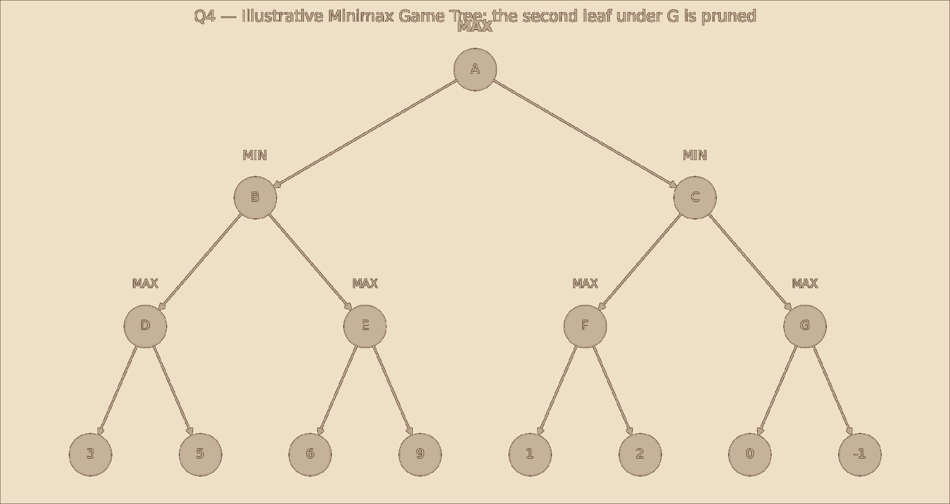
Figure 4. Illustrative game tree. The supplied question paper refers to a given tree but does not include its actual leaf values; therefore this worked example is explicitly illustrative.

4. Minimax Evaluation
Node | Type | Children Values | Result
D | MAX | 3,5 | 5
E | MAX | 6,9 | 9
B | MIN | 5,9 | 5
F | MAX | 1,2 | 2
G | MAX | 0,-1 | 0
C | MIN | 2,0 | 0
A | MAX | 5,0 | 5

Thus, in this illustrative tree, MAX chooses B because minimax(A)=max(5,0)=5.

5. Minimax Pseudocode
MINIMAX(node, depth, maximizingPlayer)
- if node is terminal or depth = 0:
- return utility(node)
- if maximizingPlayer:
- value = -∞
- for each child:
- value = max(value, MINIMAX(child, depth-1, False)) 7. return value
- else:
- value = +∞
- for each child:
- value = min(value, MINIMAX(child, depth-1, True))
- return value

6. Alpha–Beta Pruning
Alpha–Beta pruning produces the same minimax decision while avoiding branches that cannot influence the final decision. Alpha is updated at MAX nodes and beta at MIN nodes.
ALPHABETA(node, depth, alpha, beta, maximizingPlayer) 1. if terminal/depth limit: return utility(node)
- if maximizingPlayer:
- value = -∞
- for child in children:
- value = max(value, ALPHABETA(child, depth-1, alpha, beta, False))
- alpha = max(alpha, value)
- if alpha >= beta: break # prune 8. return value
- else:
- value = +∞
- for child in children:
- value = min(value, ALPHABETA(child, depth-1, alpha, beta, True))
- beta = min(beta, value)
- if alpha >= beta: break # prune
- return value

7. Pruning Trace
Stage | Observation | Action
Evaluate B | B returns 5 | At root MAX, alpha becomes 5.
Enter C | C is MIN | Its first child F returns 2, so beta becomes 2.
Compare | alpha=5 ≥ beta=2 | Remaining child G cannot improve C for  MAX.
Prune | G's remaining branch | Skip the second leaf under G.

8. Node Evaluation Comparison
Method | Illustrative Nodes Evaluated | Pruned
Minimax | 15 nodes including leaves | 0
Alpha–Beta | 13 nodes | 2 leaf evaluations skipped

The exact count depends on the supplied faculty tree and child ordering. Alpha–Beta becomes much more effective when promising moves are examined first.

9. Complexity
Method | Time Complexity | Space
Minimax | O(b^d) | O(bd) with depth-first implementation
Alpha–Beta worst case | O(b^d) | O(bd)
Alpha–Beta best case | O(b^(d/2)) with strong move ordering | O(bd)

10. Advantages & Limitations
- Advantages: Minimax gives a principled adversarial decision; Alpha–Beta preserves the same result while reducing unnecessary evaluation.
- Limitations: computational cost grows rapidly with depth; Alpha–Beta depends heavily on move ordering; heuristic evaluation is needed for large games.

11. Conclusion
Minimax determines the best move assuming optimal opposition. Alpha–Beta pruning improves efficiency without changing the final minimax decision, making deeper game-tree searches practical.

QUESTION 5 — LOCAL SEARCH / ONLINE SEARCH AGENT
A warehouse robot operates in a dynamic environment where obstacles may appear unexpectedly. Design an intelligent search strategy using either Local Search or an Online Search Agent. Explain how the algorithm adapts to environmental changes and compare its performance with informed search algorithms.

1. Problem Statement
The robot must reach a goal while obstacles can appear after planning begins. A static precomputed path may become invalid, so the robot needs a strategy that can respond to newly observed information.

2. Technique Selection
An Online Search Agent is selected because the environment is dynamic and the robot may not know the complete state of the environment in advance. The agent senses the current surroundings, chooses an action, observes the result, updates its internal knowledge, and replans.

3. Environment Representation
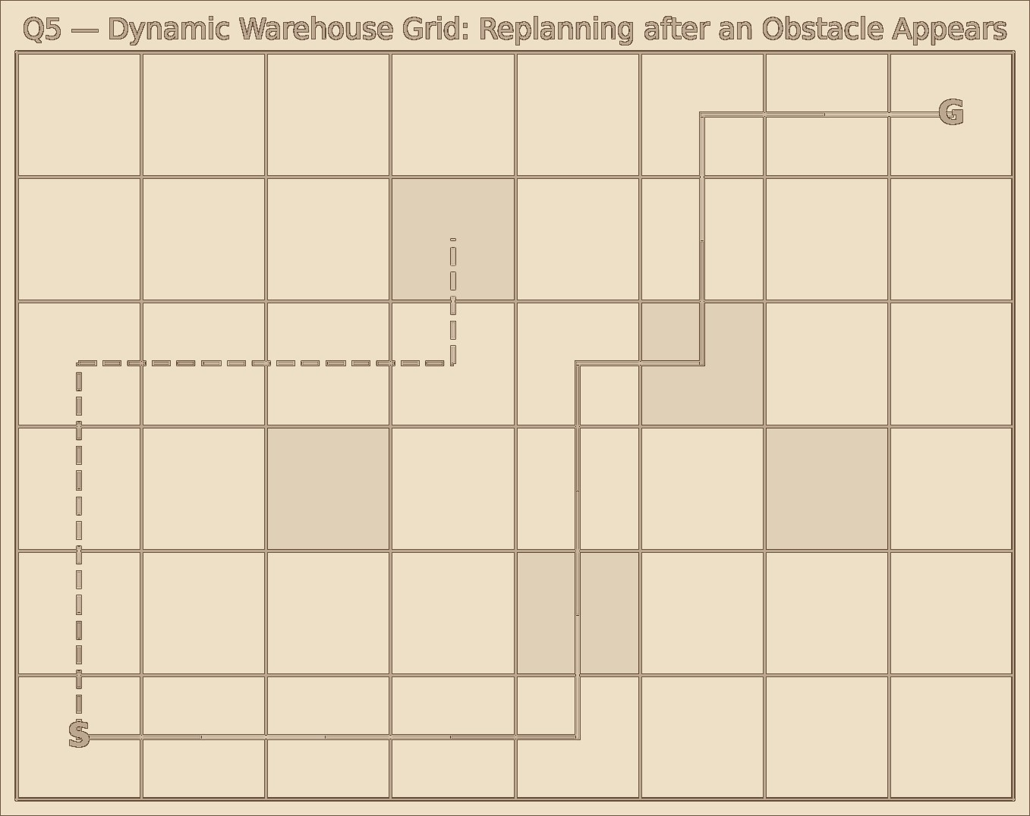
Figure 5. Illustrative warehouse grid. The dashed route represents an initial route that becomes blocked; the solid route represents a replanned path.

4. Agent Cycle
- Observe the current local environment.
- Update the internal map with newly detected obstacles.
- Estimate promising actions toward the goal.
- Execute one safe action rather than committing to an entire fixed route.
- Observe the new state and repeat.
- Replan when the current route becomes invalid.

5. Online Search Pseudocode
ONLINE-SEARCH-AGENT(start, goal)
- current ← start
- map ← initial knowledge
- while current ≠ goal:
- percept ← sense_environment()
- update(map, percept)
- if current path is blocked:
- path ← search_using_current_map(current, goal)
- else:
- path ← continue_best_known_path()
- action ← first safe action in path
- execute(action)
- current ← observe_new_state() 13. return success

6. Adaptation Example
Situation | Agent Response
Initial path is clear | Follow the planned route.
Obstacle appears | Detect it through sensing.
Current route blocked | Update map and replan.
New route available | Execute the next safe action.
Another obstacle appears | Repeat sensing and replanning.

7. Comparison with Informed Search
Aspect | Online Search Agent | Static Informed Search
Environment | Can handle changing/unknown conditions | Usually assumes a sufficiently known model
Planning | Interleaves planning and action | Plans before execution
Adaptability | High | Lower if the environment changes after planning
Knowledge | Learns through observations | Uses the supplied model/heuristic
Risk | Can react to unexpected obstacles | May follow an invalidated plan
Typical use | Robotics, exploration, dynamic navigation | Static route planning

8. Complexity
The total computational cost depends on how often replanning is triggered and the search algorithm used internally. If a search over N states is performed after each major change, the overall cost is approximately the sum of the costs of those repeated searches rather than one fixed search.

9. Advantages & Limitations
- Advantages: adapts to new information; suitable for dynamic environments; can make safe incremental decisions; supports continuous replanning.
- Limitations: repeated planning can increase computation; early decisions may be suboptimal; sensing errors can affect performance; quality depends on the replanning strategy.

10. Conclusion
An Online Search Agent is appropriate for a warehouse robot operating under unexpected changes. By sensing, updating its map and replanning, the robot can continue toward the goal even when the original route becomes unavailable.

EVALUATION RUBRICS

Criteria | Weightage | Excellent | Good | Average | Poor (<60%)

 | (%) | (90–100%) | (75–89%) | (60–74%)
Problem  Analysis and  Understanding | 15% | 13–15% –  Clearly identifies the problem, initial state, goal state, constraints, and expected outcome. | 10–12% –  Identifies most problem components with minor omissions. | 7–9% – Demonstrates partial understanding with some missing elements. | 0–6% – Incorrect or incomplete understanding of the problem.
AI Algorithm  Selection &  Justification | 15% | 13–15% –  Selects the most appropriate AI algorithm/searc h technique with strong technical justification. | 10–12% –  Selects an appropriate algorithm with adequate justification. | 7–9% –  Selects a partially suitable algorithm with limited justification. | 0–6% – Incorrect algorithm selection or no justification.
Algorithm  Design /  Pseudocode | 25% | 22–25% – Designs a complete, logical, efficient, and error-free algorithm/pseu docode. | 17–21% –  Algorithm is mostly correct with minor logical errors. | 12–16% –  Algorithm is partially complete with several logical errors. | 0–11% –  Algorithm is incomplete, incorrect, or difficult to understand.
Application of  AI Concepts  (Greedy, A*,  CSP, Minimax, Alpha-Beta,  etc.) | 15% | 13–15% – Correctly applies the relevant AI concepts and techniques throughout the solution. | 10–12% – Applies AI concepts correctly with minor mistakes. | 7–9% – Demonstrates limited application of AI concepts. | 0–6% – Unable to apply the appropriate AI concepts or techniques.
Diagram / State  Space / Search  Tree  Representation | 10% | 9–10% – Accurate, complete, and well-labelled diagram supporting the solution. | 7–8% – Diagram is mostly correct with minor omissions. | 5–6% – Diagram is partially complete or lacks clarity. | 0–4% – Diagram is missing or incorrect.
Complexity  Analysis and  Solution  Efficiency | 10% | 9–10% – Correctly analyzes time and space complexity and proposes an efficient solution. | 7–8% – Complexity analysis is mostly correct with minor errors. | 5–6% –  Partial complexity analysis or limited discussion of efficiency. | 0–4% – No meaningful complexity analysis or highly inefficient solution.
Originality,  Critical  Thinking, and  Presentation | 10% | 9–10% – Demonstrates excellent originality, logical reasoning, organized presentation, and explores optimized/alter native solutions. | 7–8% – Demonstrates good critical thinking with a clear presentation. | 5–6% –  Shows limited originality and acceptable presentation. | 0–4% – Poor presentation with little or no critical thinking.

